

Project Name: Maid on Demand

Sept- 2021.

Documentation On

**“Maid on Demand”**

E-DAC Sept2021

**Guided By: Monika Shivankar**

Submitted By :

**Group No: 23**

* **Manish Kumar 210**
* **RoshiniVerma 210543081094**
* **Shiksha Sharma 210543081107**
* **SwapnilShashikantPawar210543081115**

**Table of Contents**

**1. Introduction 4**

1.1 Document Purpose **4**

1.2 Project Background **4**

1.3 Aim & Objectives **4**

**2. Business RequirementsOverview**…………………………………………………………**5**

**3.Functional Requirements** **5**

3.1 Customer Module **5**

3.2 Owner Module **6**

3.3 Admin Module **6**

**4.Non-FunctionalRequirement………………………………………………………………6**

**5. Use Case Diagram 7**

5.1 Admin **7**

5.2 Customer **8**

5.3 Owner **9**

**6. Database Design 10**

1 Customer **10**

2 Owner **10**

3 Login…………………………………………………………………………………… **10**

4 Booking **11**

5 Payment **11**

**7.E-R Diagram………………………………………………………………………………………12**

**8. Snapshots 13**

**9. Conclusion 25**

**List of Figures**

**Use Case Diagrams 7**

Fig 1 Admin 7

Fig 2 Customer 8

Fig 3 Owner 9

Fig 4 ER Diagram 12

1. **Introduction:**
   1. **DocumentPurpose:**

Online Maid Booking System is a system created to provide household help services to the customers

## Project Background:

As we move to new city or place, it’s become quite troublesome to search for maid and then end up with no option...

So keeping in mind the problem we come up to the solution of booking online Maid ... where customer can book maid online by visiting our website.

## Aim & Objectives:

The main objective of this project is building a website which will help maids to get the work.

Booking software is the backend of a business's online website. It empowers business owners to easily create a website to provide maids easily available by booking them for helping in household works like cleaning, washing, cooking, etc.

Here if suppose some maids want to use this facility and want to learn how it is possible and how they can use e-booking to register, they must have knowledge of computer then they can directly register in the site and get the work.

On the other side, customer can also register and book maid online as per their needs.

# Business Requirements Overview

* Maid booking system is the public web application.
* Maid booking system will be opened to the global, but in the phase 1, the main target is in the India.
* There are mainly two types of user. One is the Customer and other is Maid.
* Customer can search for the maid available for household work.
* Maid booking system provides the functions which connect the customers and the maid efficiently.
* Maid booking system could be maintained by Administrator.

# Functional Requirements Overview

Maid booking system consists of four modules described as below.

1. Customer Module
2. Maid Module
3. Admin Module
4. Message Acknowledgement Module

# 3.1 **Customer Module**

* Customer can register and create their account.
* Maid booking system provides the function which allows customer to search and book maid as per their need.
* Customer is able to browse existing list price of maid.
* Customer can view the history of their previous booked maid.
* Customer is redirected to payment gateway for online payment.
* Customer can update personal details.

# 3.2 **Maid Module**

* Maid can register and create their account.
* Maid booking system provides the function which allows maid to get the work.
* Maid can update personal details.

# 3.3 **Admin Module**

* Maid booking system should provide all function to admin how to handle the System.
* What are the customer and maid are using this system and are they authorized.
* Could able to know all the Transaction.

# 3.4 **Message Acknowledgement Module**

* Message Acknowledge Module should provide the entire users feedback message about their completion of transaction.
* Message Acknowledgement will send to both customer and maid for the booking.

# Non-functional Requirements

* The website should use professional design, look and feel and color scheme.
* Users will have no limitations for accessing the application through Internet. The portal being an internet application, it is difficult specify exact number of visitor or users. Hence we will target the system to support between 5 and 10 million users on launch of phase 1.
* Being a public website, the site must follow general usability guidelines for menus, navigation, colors, links and other actions provided on the screens.
* The system should be designed in such a manner that user will be able to complete tasks in minimum number of steps.

.

## 5. Use-CaseDiagram

**5.1 Admin:**

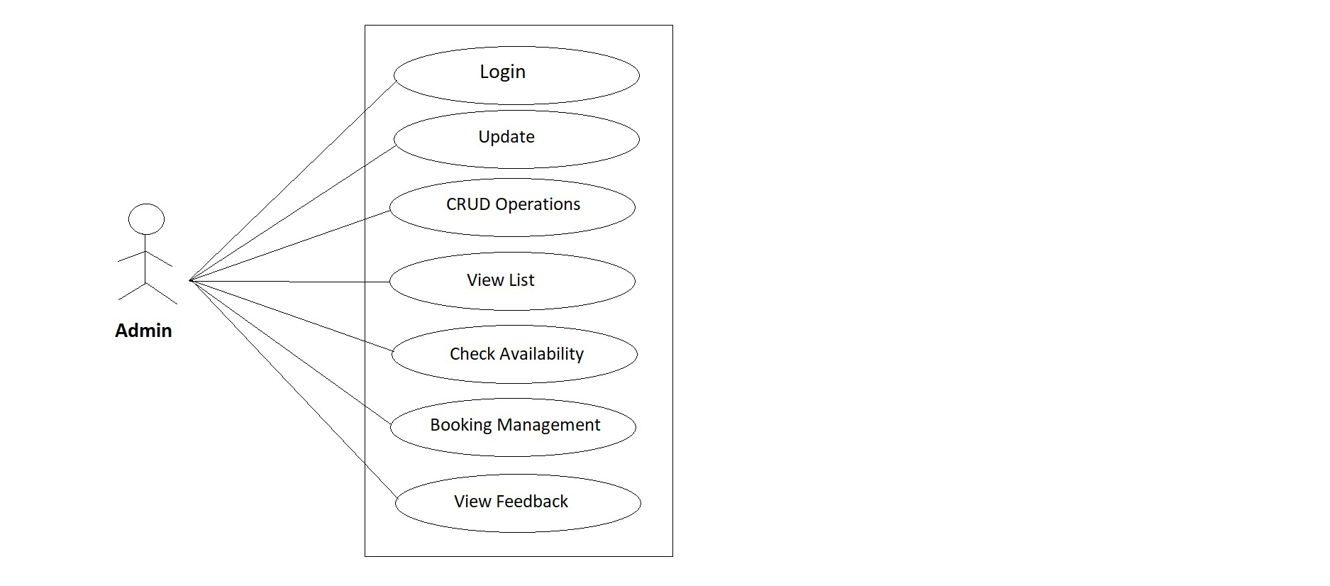

Fig. Use-Case Diagram for Admin

## 5.2Customer:

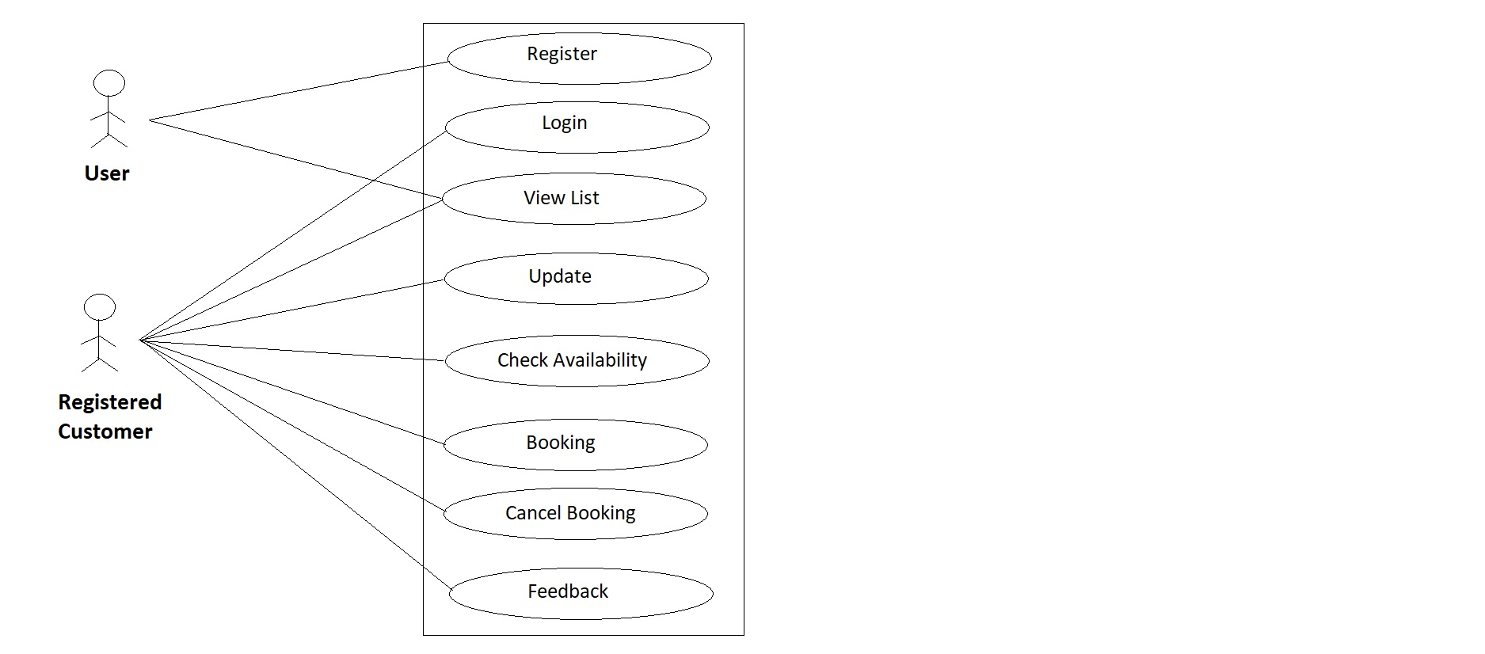

Fig. Use-Case Diagram for Customer

**5.3 Owner:**

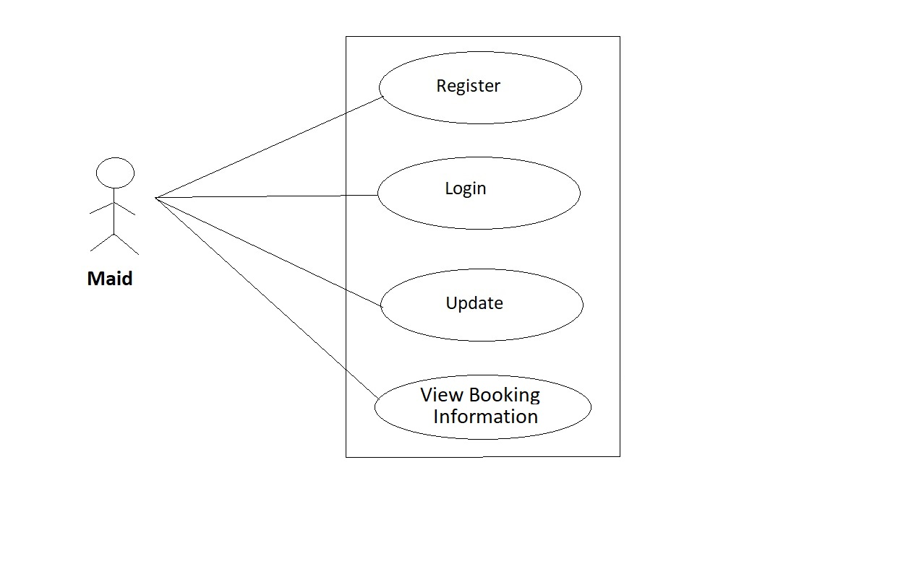

Fig. Use-Case Diagram for Maid

**6. Database Design:**

**1] Tbl_Maid**

|  |  |  |  |  |  |
| --- | --- | --- | --- | --- | --- |
| **Fields** | **Data Type** | **Constraint** | **Default** | **Null** | **Description** |
| maid_id | int | Primary Key | AI | NO | Maid ID |
| m_name | varchar(100) |  | NULL | NO | Maid Full Name |
| gender | varchar(10) |  | NULL | NO | Gender(male/female/other) |
| marital_status | varchar(20) |  | NULL | NO | Married/Single |
| address | varchar(100) |  | NULL | NO | Permanent Address |
| contactno | varchar(10) |  | NULL | NO | Contact no. of maid |
| aadhar_card | varchar(12) |  | NULL | NO | 12 digit Aadhar Card no/image |
| is_active | varchar(1) |  | NULL | NO | Active or deactive/available or Not |
| created_date | date |  | NULL | NO | date of register |

**2] Tbl_Customer**

|  |  |  |  |  |  |
| --- | --- | --- | --- | --- | --- |
| **Fields** | **Data Type** | **Constraint** | **Default** | **Null** | **Description** |
| cid | int | Primary Key | AI | NO | Customer ID |
| c_name | varchar(100) |  | NULL | NO | Customer Full Name |
| gender | varchar(10) |  | NULL | NO | Gender(male/female/other) |
| family_status | varchar(20) |  | NULL | NO | Family/Single |
| address | varchar(100) |  | NULL | NO | Permanent Address |
| email_id | varchar(100) |  | NULL | NO | Email Addrees |
| aadharcard | varchar(12) |  | NULL | NO | 12 digit Aadhar Card no/image |
| user_id | varchar(50) |  | NULL | NO | User ID for account login |
| password | varchar(50) |  | NULL | NO | Account Password |
| contactno | varchar(10) |  | NULL | NO | Contact no. of customer |

**3] Tbl_Feedback**

|  |  |  |  |  |  |
| --- | --- | --- | --- | --- | --- |
| **Fields** | **Data Type** | **Constraint** | **Default** | **Null** | **Description** |
| feedback_id | int | Primary Key | AI | NO | Feedback ID |
| cid | int | Foreign Key | NULL | NO | Reference to Customer ID in (Customer table) |
| rating | int |  | NULL | YES | Rating According to service |
| comment | varchar(200) |  | NULL | YES | Comment according to service |

**4] Tbl_Category**

|  |  |  |  |  |  |
| --- | --- | --- | --- | --- | --- |
| **Fields** | **Data Type** | **Constraint** | **Default** | **Null** | **Description** |
| category_id | int | Primary Key | AI | NO | Category ID |
| category_name | varchar(50) |  | NULL | NO | Cooking/Cleaning/Washing |
| charges | decimal(10,2) |  | NULL | NO | Charges according to category |
| mid | int | Foreign Key | NULL | NO | Reference to maid_id in (maid table) |

**5] Tbl_Message**

|  |  |  |  |  |  |
| --- | --- | --- | --- | --- | --- |
| **Fields** | **Data Type** | **Constraint** | **Default** | **Null** | **Description** |
| msg_id | int | Primary Key | AI | NO | Category ID |
| cid | int | Foreign Key | NULL | NO | Cooking/Cleaning/Washing |
| mid | int | Foreign Key | NULL | NO | Charges according to category |
| msg_desc | varchar(100) |  | NULL | NO | Reference to maid_id in (maid table) |

**6] Tbl_BookingInfo**

|  |  |  |  |  |  |
| --- | --- | --- | --- | --- | --- |
| **Fields** | **Data Type** | **Constraint** | **Default** | **Null** | **Description** |
| book_id | int | Primary Key | AI | NO | Booking ID |
| cid | int | Foreign Key | NULL | NO | reference to Customer ID in (Customer table) |
| mid | int | Foreign Key | NULL | NO | Reference to maid_id in (maid table) |
| payment | decimal(10,2) |  | NULL | NO | Payment according to service and category selected |
| start_date | date |  | NULL | NO | Service start date |
| end_date | date |  | NULL | NO | Service end date |
| booking_date | date |  | NULL | NO | Date of booking |
| cancel | boolean |  | NULL | YES | want to cancel booking |

## 7. ER-Diagram:

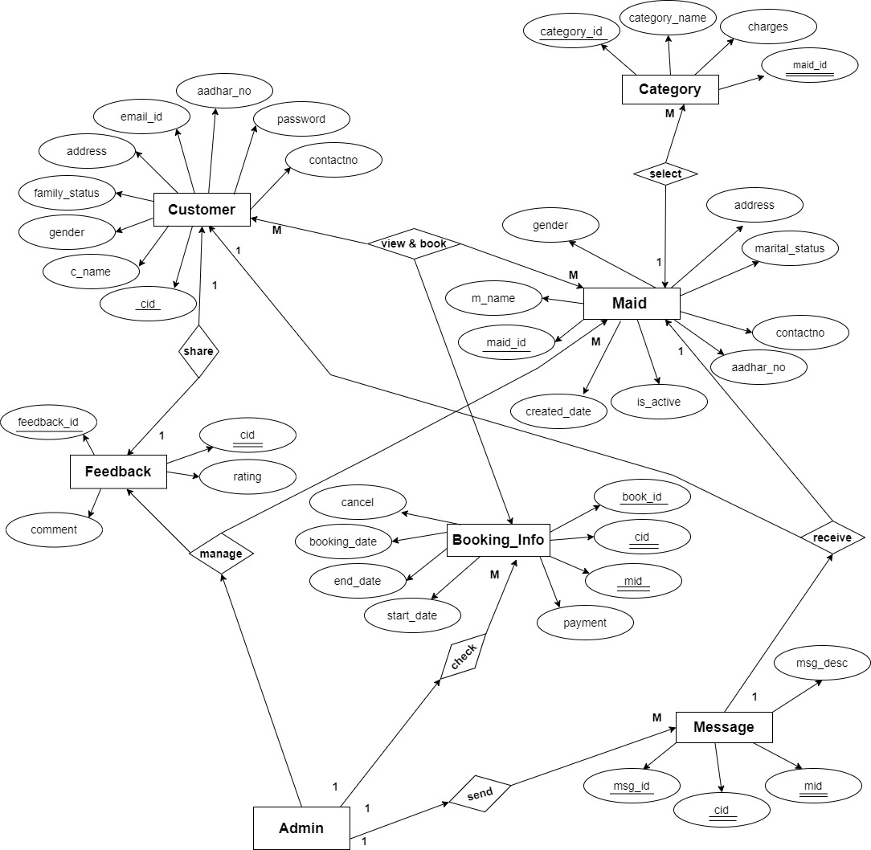

**E-R diagram shows database ofOnline Maid Booking**

**8. Snapshots:**

**8.1 Home Page:**

Following snapshot shows the Home page for Online Maid Booking System

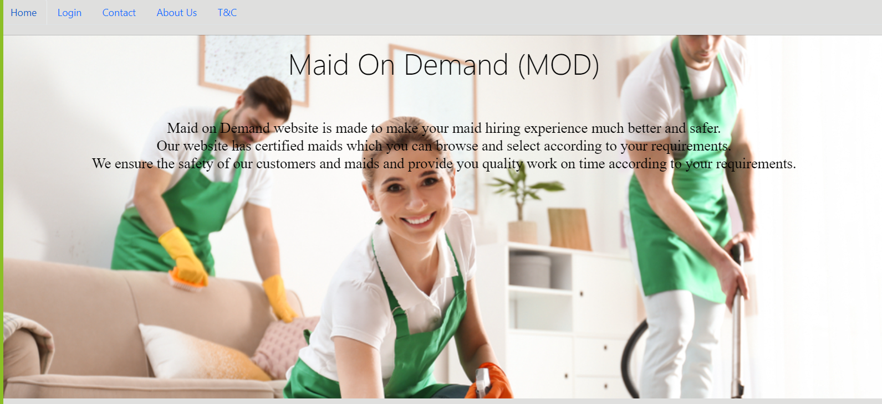

This page contains following controls

* Home
* Login
* Customer Registration
* About Us
* Contact Us

**8.2 ContactAnd About Page**

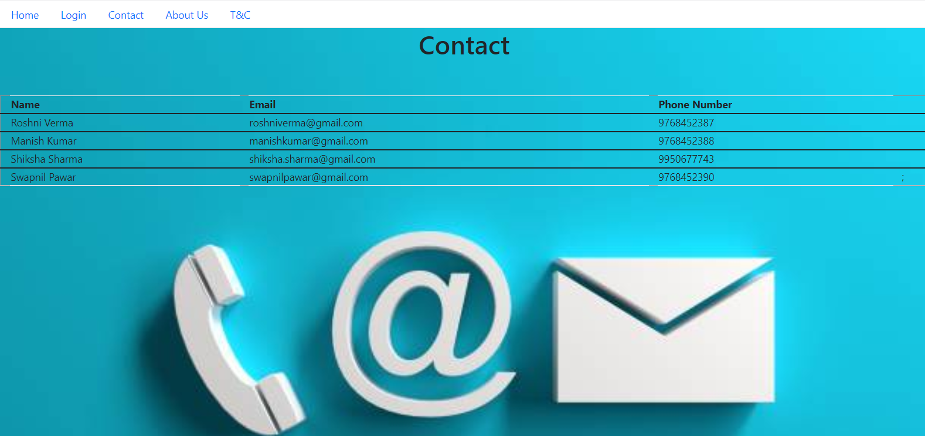

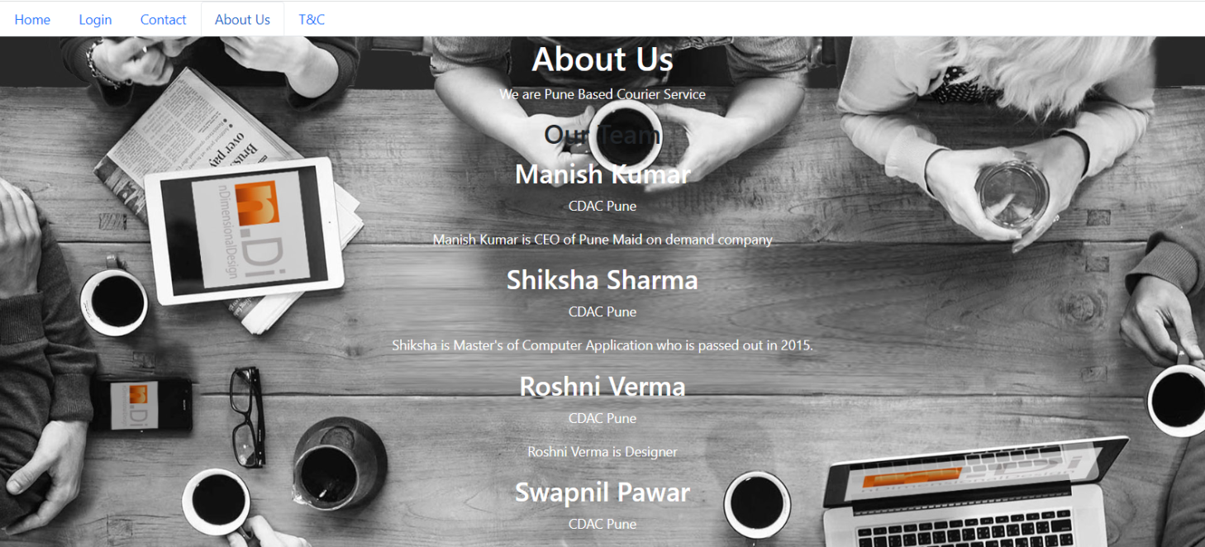

**8.3Login Page**

Following snapshot shows the Login page for Online Maid Booking System

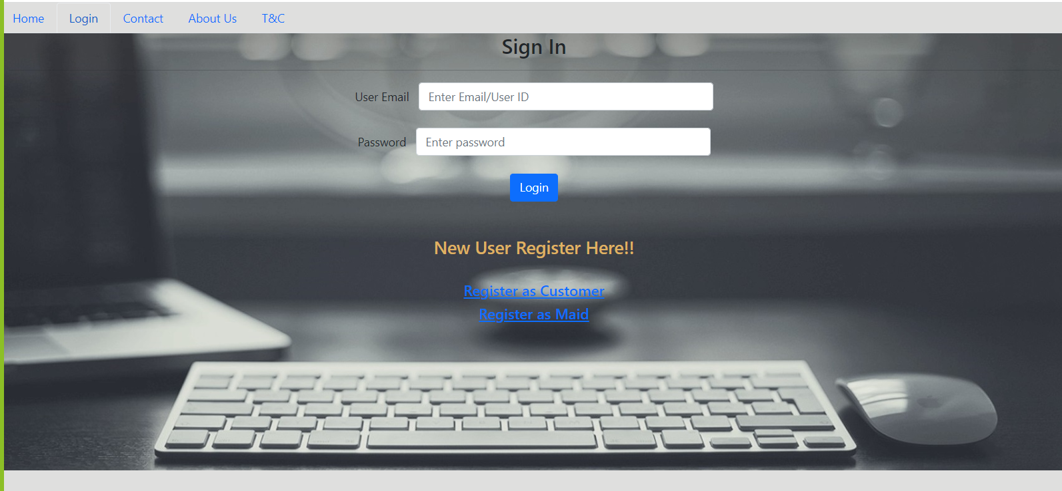

**8.4Customer Registration Page**

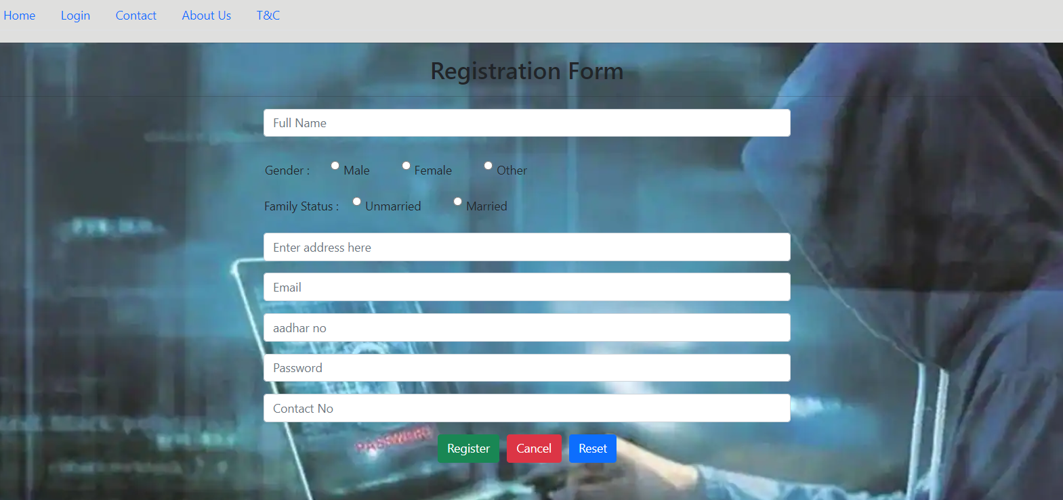

**8.5Maid Registration Page**

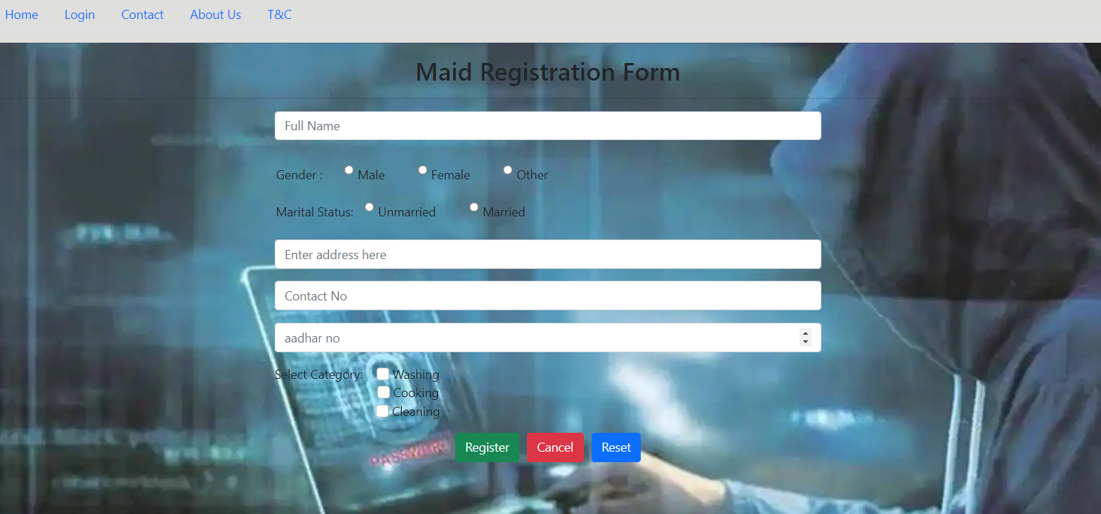

**8.6Customer Booking Maid**

**8.6.1 Customer Home page After Successful login**

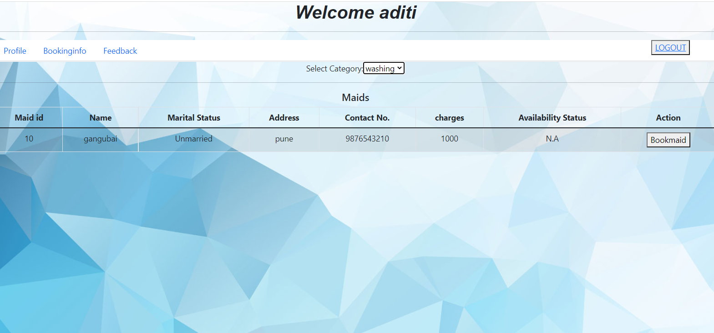

**8.6.2 Customer Viewing Maid for Category Cleaning**

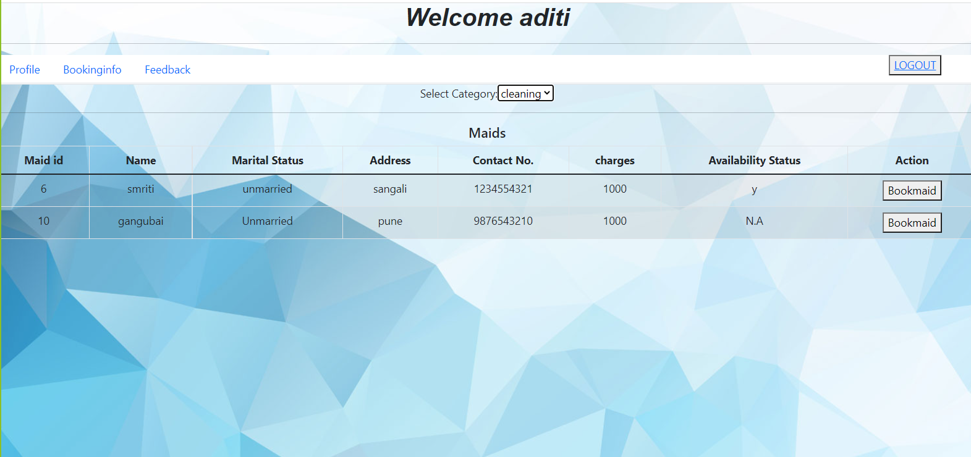

**8.6.3Customer Viewing Maid for Category Cooking**

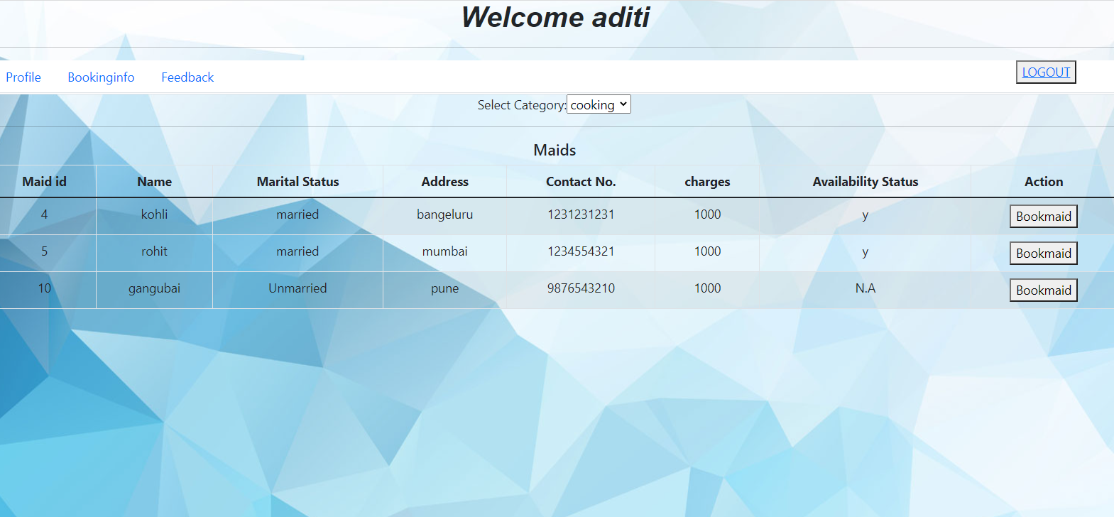

**8.6.4 Booking Page**

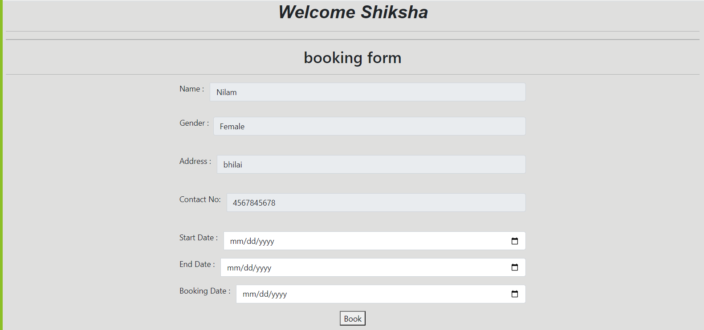

**8.6.5 Booking Info (the bookings made by customer)**

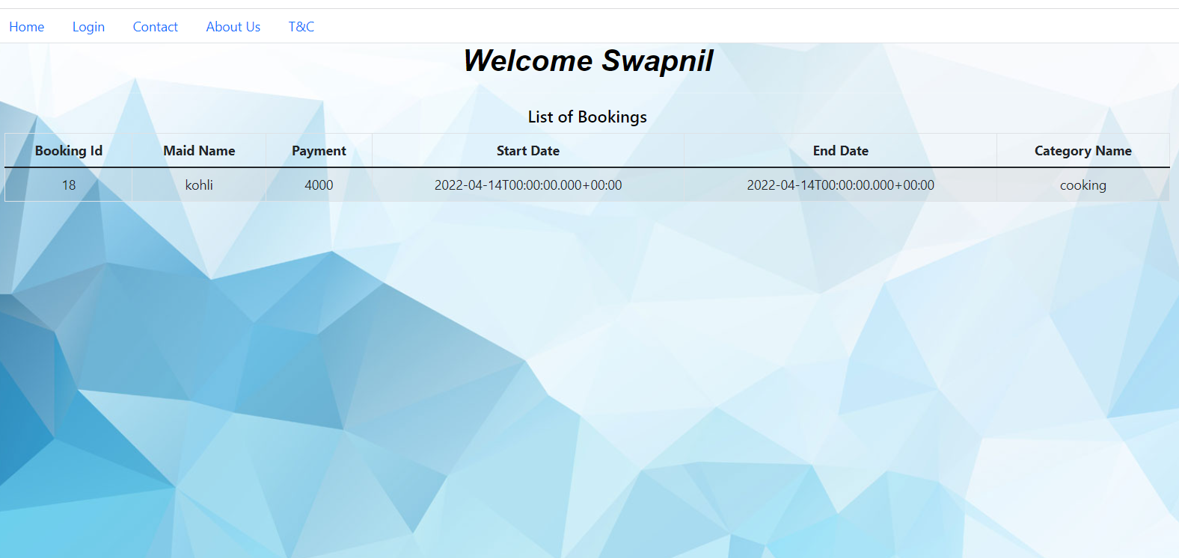

**8.6.6Customer Feedback Form**

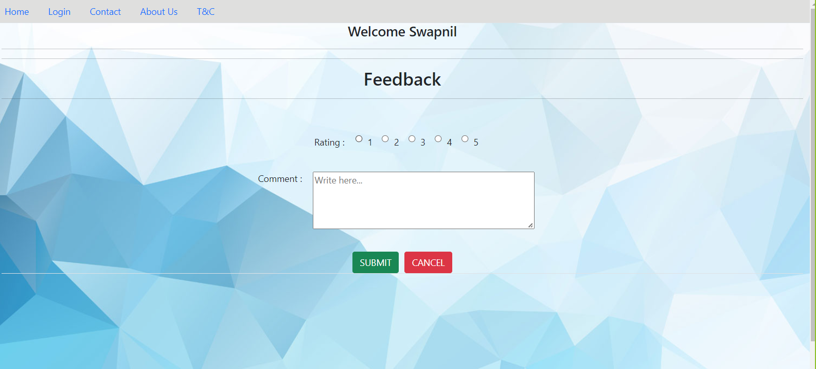

**8.6.7customer Personal Info(customer can update personal info )**

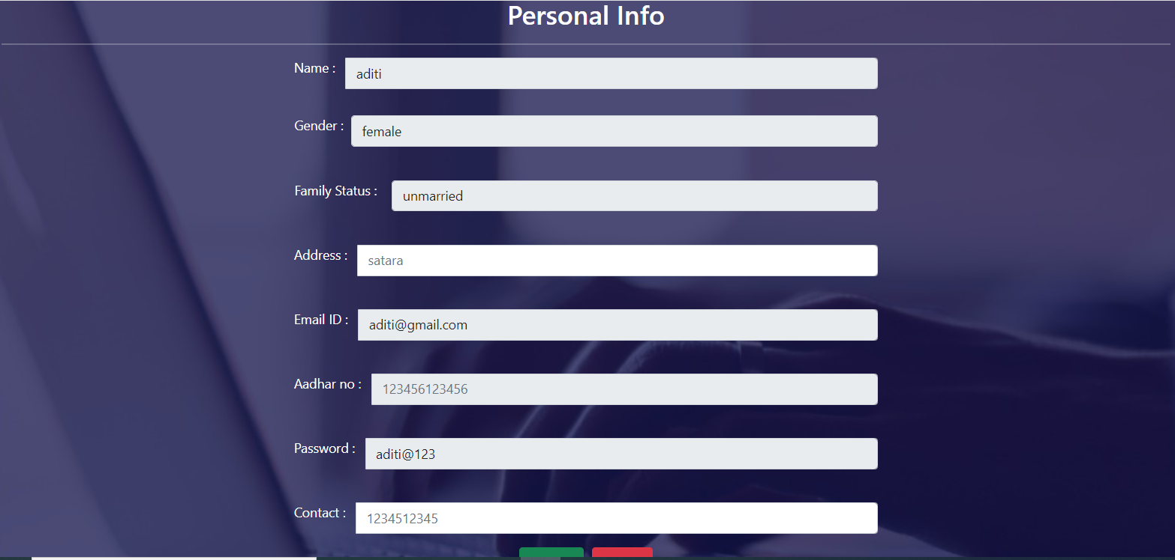

**8.7.7 Maid Update Profile Page updated by Admin**

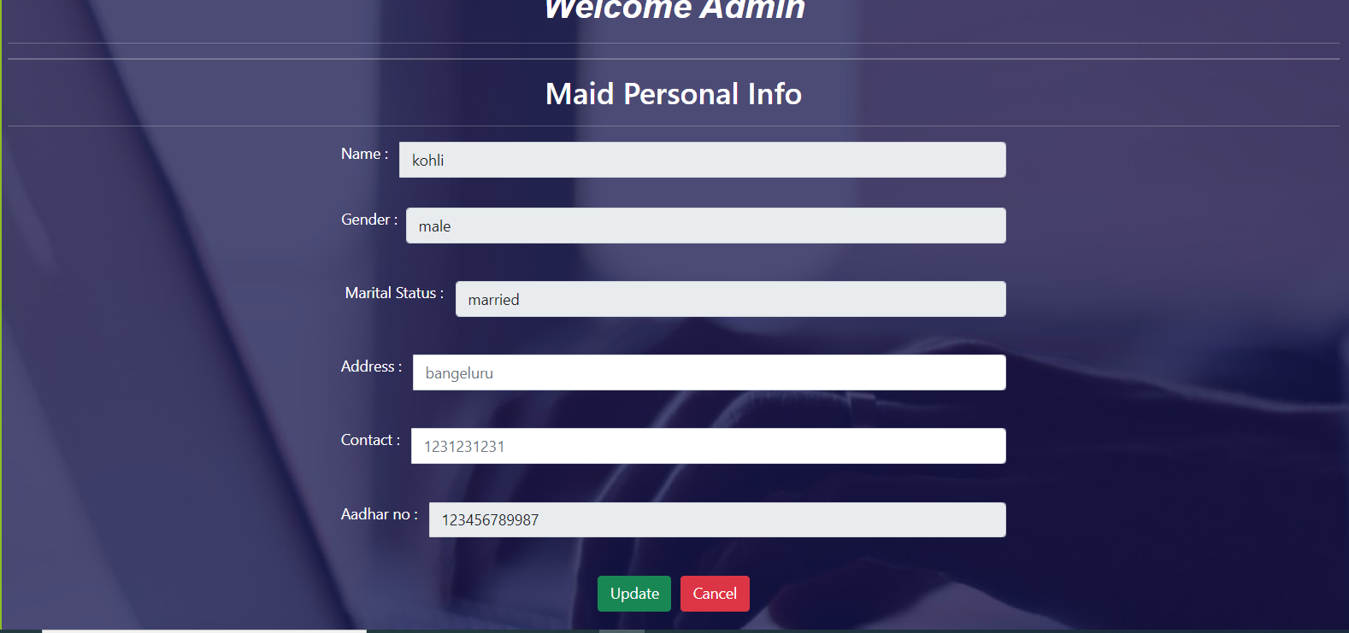

**8.8 Admin**

**8.8.1 Admin Home Page**

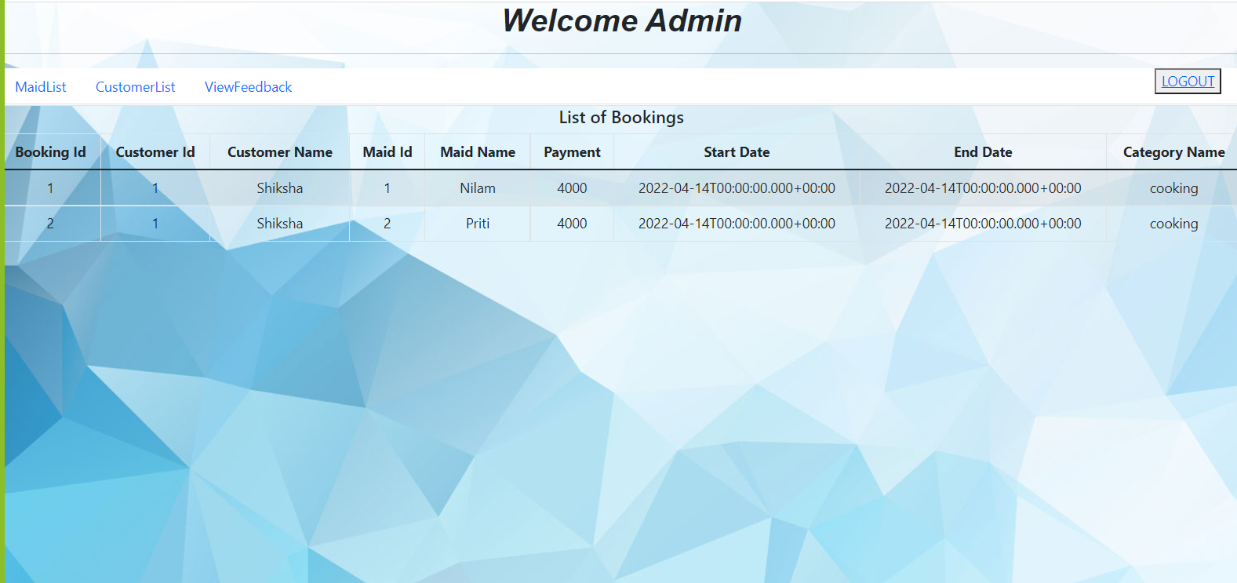

**8.8.2 Maid Details for Admin**

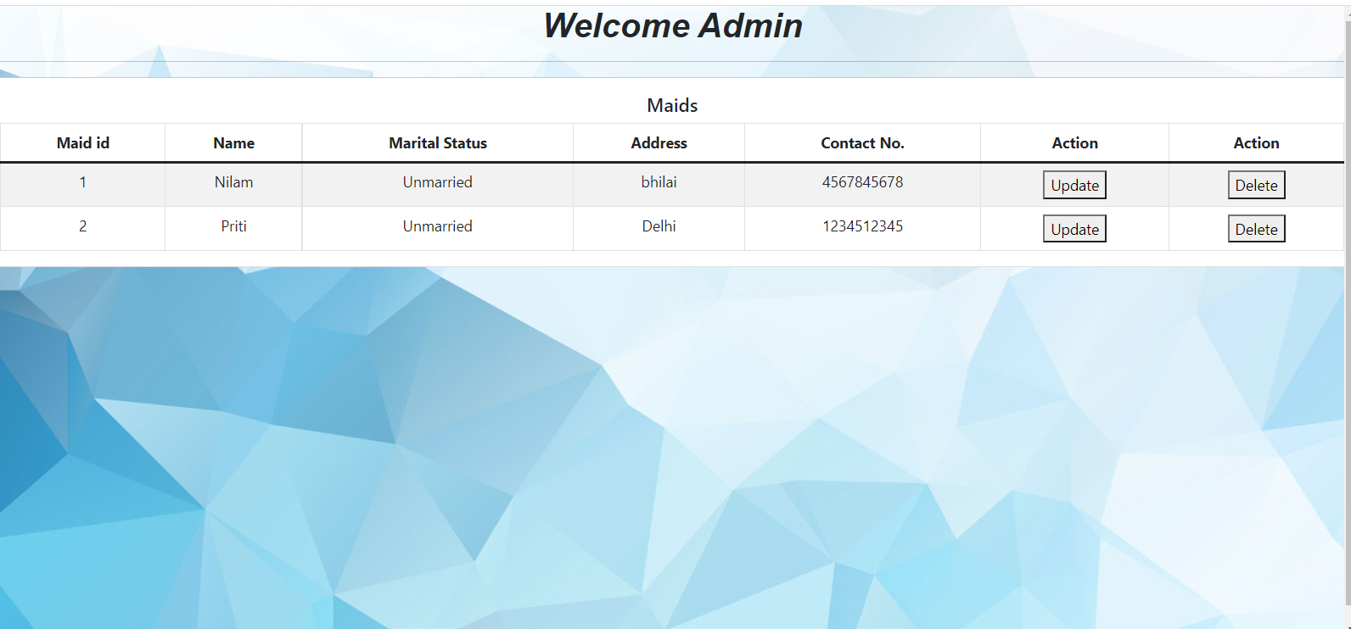

**8.8.3 Maid Profile Page**

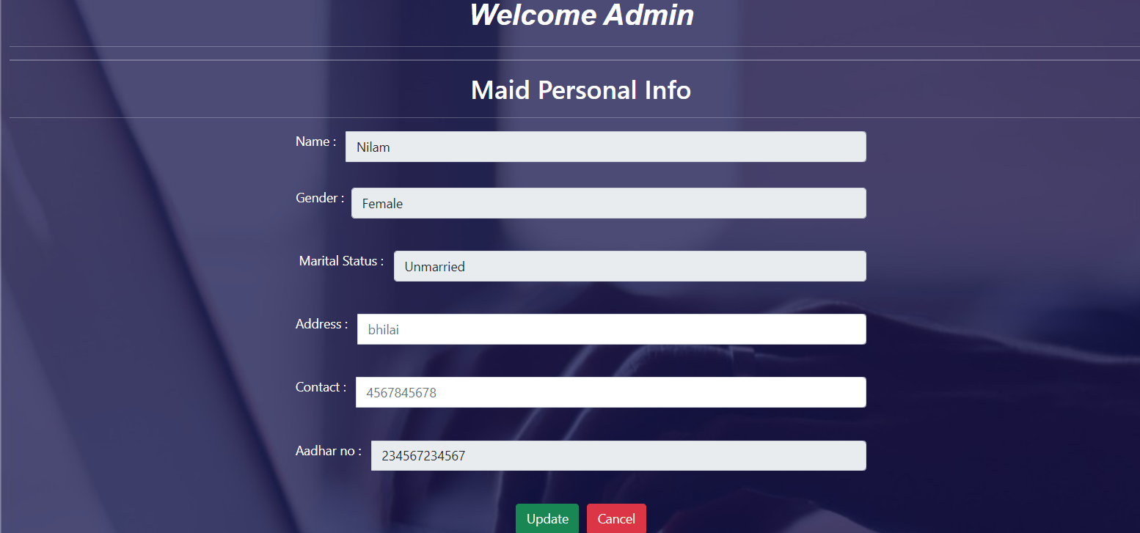

**8.8.4 Customer Details Page**

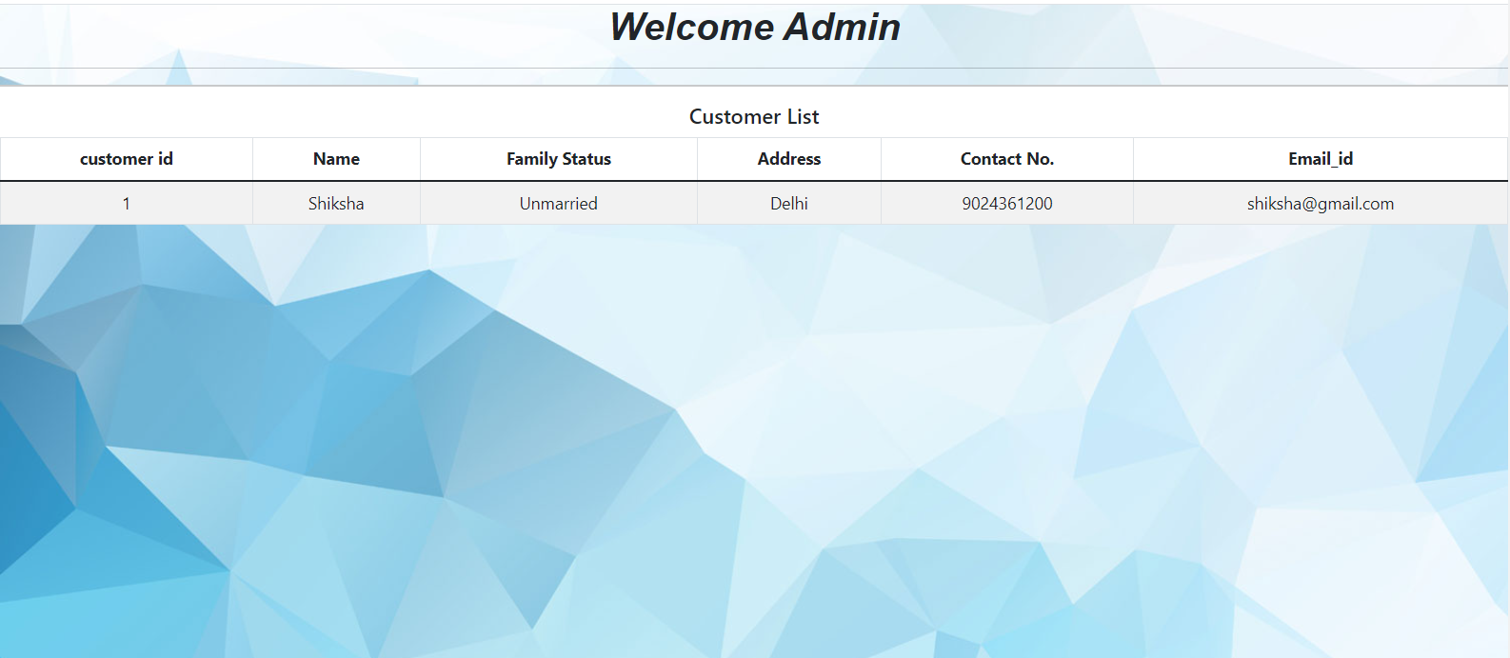

**8.8.5 List of Feedback given by customer**

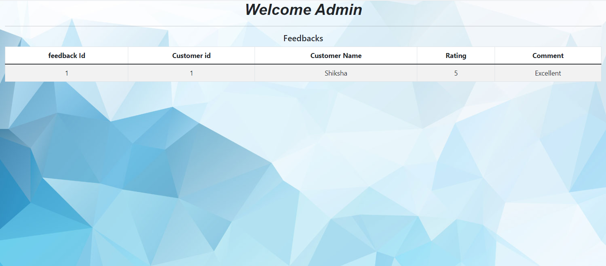

**9. CONCLUSION AND FUTURESCOPE**

Online Car & Bike Rental System provides better Vehicle booking on rent platform to customer and Owner can get the business for their vehicle efficiently.

Our System provides a very user-friendly platform where Customer can easily search the vehicle, Book the vehicle, see the booking and Make payment for vehicle booking on rent also Owner will Register the vehicle, See the vehicle booking and owner can also delete the register vehicle.

Our system is aimed efficient management of various tasks like booking the vehicle for Customer on daily basis, managing payment for booking, adding the vehicle. Monitor daily Booking along with managing all the Account and information on a single platform.